Practical no:-7
package javaapplication6;

import javax.swing.*;
import javax.swing.tree.DefaultMutableTreeNode;

/**
*
* @author DELL
*/
public class JTreedemo1 extends JFrame
{
JFrame frame;
JTreedemo1()
{
frame =new frame();
DefaultMutableTreeNode Thispc = new DefaultMutableTreeNode("This pc");
DefaultMutableTreeNode os = new DefaultMutableTreeNode("os");
DefaultMutableTreeNode Drive = new DefaultMutableTreeNode("Drive F");

Thispc.add(os);
Thispc.add(Drive);

DefaultMutableTreeNode Folder = new DefaultMutableTreeNode("ajp");
DefaultMutableTreeNode Folder1 = new DefaultMutableTreeNode("vs");
Thispc.add(Folder);
Thispc.add(Folder1);

JTree i = new JTree(Thispc);
frame.add(i);
frame.setSize(200, 200);
frame.setVisible(true);
}
public static void main(String args[])
{
JTreedemo1 JTreedemo = new JTreedemo1();

}

}

OUTPUT

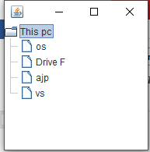

package javaapplication6;

import javax.swing.*;
import javax.swing.tree.DefaultMutableTreeNode;

/**
*
* @author DELL
*/
public class JTreedemo extends JFrame
{
JFrame frame;
JTreedemo()
{
frame =new frame();
DefaultMutableTreeNode style = new DefaultMutableTreeNode("style");
DefaultMutableTreeNode color = new DefaultMutableTreeNode("color");
DefaultMutableTreeNode font = new DefaultMutableTreeNode("font");

style.add(color);
style.add(font);

DefaultMutableTreeNode purple = new DefaultMutableTreeNode("Brown");
DefaultMutableTreeNode yellow = new DefaultMutableTreeNode("pink");
color.add(purple);
color.add(yellow);

JTree i = new JTree(style);
frame.add(i);
frame.setSize(200, 200);
frame.setVisible(true);
}
public static void main(String args[])
{
JTreedemo JTreedemo = new JTreedemo();

}

}

Output

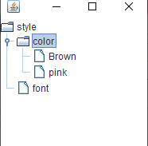

package javaapplication6;

import javax.swing.*;
import javax.swing.tree.DefaultMutableTreeNode;

/**
*
* @author DELL
*/
public class JTreedemo2 extends JFrame
{
JFrame frame;
JTreedemo2()
{
frame =new frame();
DefaultMutableTreeNode Language = new DefaultMutableTreeNode("Language");
DefaultMutableTreeNode Frontend = new DefaultMutableTreeNode("Frontend");
Language.add(Frontend);

DefaultMutableTreeNode purple = new DefaultMutableTreeNode("HTMI");
DefaultMutableTreeNode yellow = new DefaultMutableTreeNode("css");
Frontend.add(purple);
Frontend.add(yellow);

DefaultMutableTreeNode Backend = new DefaultMutableTreeNode("Backend");

Language.add(Backend);

DefaultMutableTreeNode purple1 = new DefaultMutableTreeNode("SQL");
DefaultMutableTreeNode yellow1 = new DefaultMutableTreeNode("Database");
Backend.add(purple1);
Backend.add(yellow1);

JTree i = new JTree(Language);
frame.add(i);
frame.setSize(200, 200);
frame.setVisible(true);
}
public static void main(String args[])
{
JTreedemo2 JTreedemo = new JTreedemo2();

}

}

OUTPUT:-

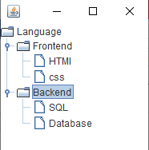

PRACTICAL NO 1
Q1]

package javaapplication3;

import java.applet.Applet;
import java.awt.*;

/**
*
* @author DELL
* <applet code="checkboxd">
*/
public class checkboxd extends Applet
{
public void init()
{

Checkbox chb1 = new Checkbox("male",true);
Checkbox chb2 = new Checkbox("female",false);
Checkbox chb3 = new Checkbox("tanssgener",false);
add(chb1);
add(chb2);
add (chb3);

}

}

OUTPUT:-

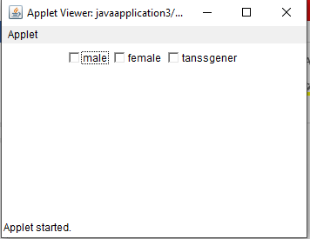

PRACTICAL NO:-2
import java.applet.Applet;
import java.awt.*;

/**
*
* @author DELL
*/
public class List1 extends Applet
{
public void init()
{
List l1 = new List(10,true);
l1.add("Mumbai");
l1.add("pune");
l1.add("Satara");
l1.add("Delhi");
l1.add("Nashik");
l1.add("Nagpur");
l1.add("Vita");
l1.add("Sangli");
l1.add("Thane");
l1.add("Katraj");
add(l1);
}
}
OUTPUT:-

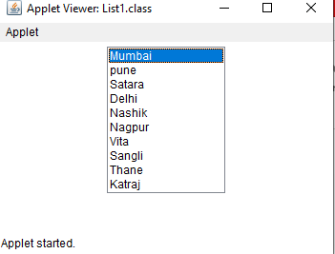

PRACTICAL NO 3
import java.applet.Applet;
import java.awt.*;

/**
*
* @author DELL
*/
public class grid extends Applet {

public void init() {
GridLayout g1 = new GridLayout(4,3);
setLayout ( g1);
for(int i=0;i<=9;i++)
{
add(new Button(" " +i));
}
}

}

OUTPUT:-

